Step 1: create the project based on swift and storyboard.

Step 2: open terminal and go to the path of the project

For me:

cd desktop

cd cmpe277hw2

step 3: check the project status

git init

git add .

git status

step 4: use Cocoapods and framework for the project, create a new pod file then

pod init

step 5: create the structure for this project. Add following group in the project: Model, Views, ViewModels, Controllers, Resources.

Step 6: Drag default file AppDelegate.swift and ScenceDelegate to resources group. Drag ViewControllers.swift to Controllers group. Drag Main.storyboard, Assets.xcassetsand LaunchScreen.storyborad to Views group.

Step 7: Change ViewController.swift to ConversationsViewController.

This is the default setting:

Step 8: In the Controllers, create Cocoa touch class named LoginViewController.swift, RegisterViewController.swift,PhotoViewerViewController.swift,NewConversationViewController.swift, ProfileViewController.swift .

Step 9: Build ConversationViewController View.

Step 10: Login page first step

Step 11: drag an image to Assets and name it as logo.

Step 12: To make building UI efficient, create a class named extension.

Step 13: build login UI and register UI, firstly build login UI and paste whole to RegisterViewController and change the class name.

Step 14: Register Page

Step 15: Add policy to allow user to take profile picture



Step 16:photo picker part

Step 17: edit pod file for firebase

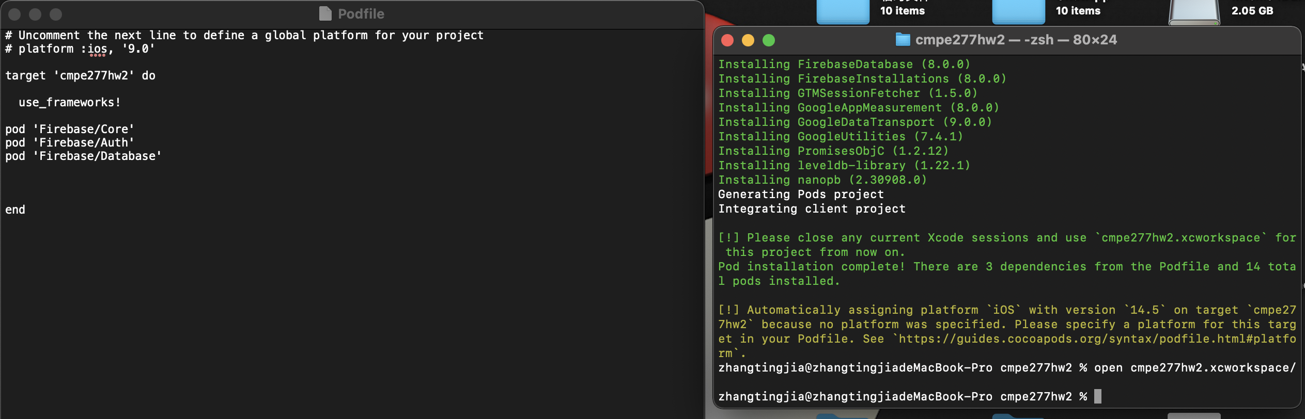

Step 18: